Erin

Assigned to: Natasha

Reporting Month: March 2025

# Results and Discussion

# Appendix A: SGS Tables & Graphs

## Raw Sewage Table

|  |  |  |  |
| --- | --- | --- | --- |
| Date | cBOD5 | TSS | TKN |
| 10-Jan-25 | 194 | 37 | 80.1 |
| 24-Jan-25 | 170 | 42 | 82 |
| 06-Feb-25 | 74 | 48 | 41 |
| 21-Feb-25 | 14 | 20 | 9.7 |
| 07-Mar-25 | 198 | 60 | 77.1 |
| 21-Mar-25 | 199 | 69 | 92.4 |

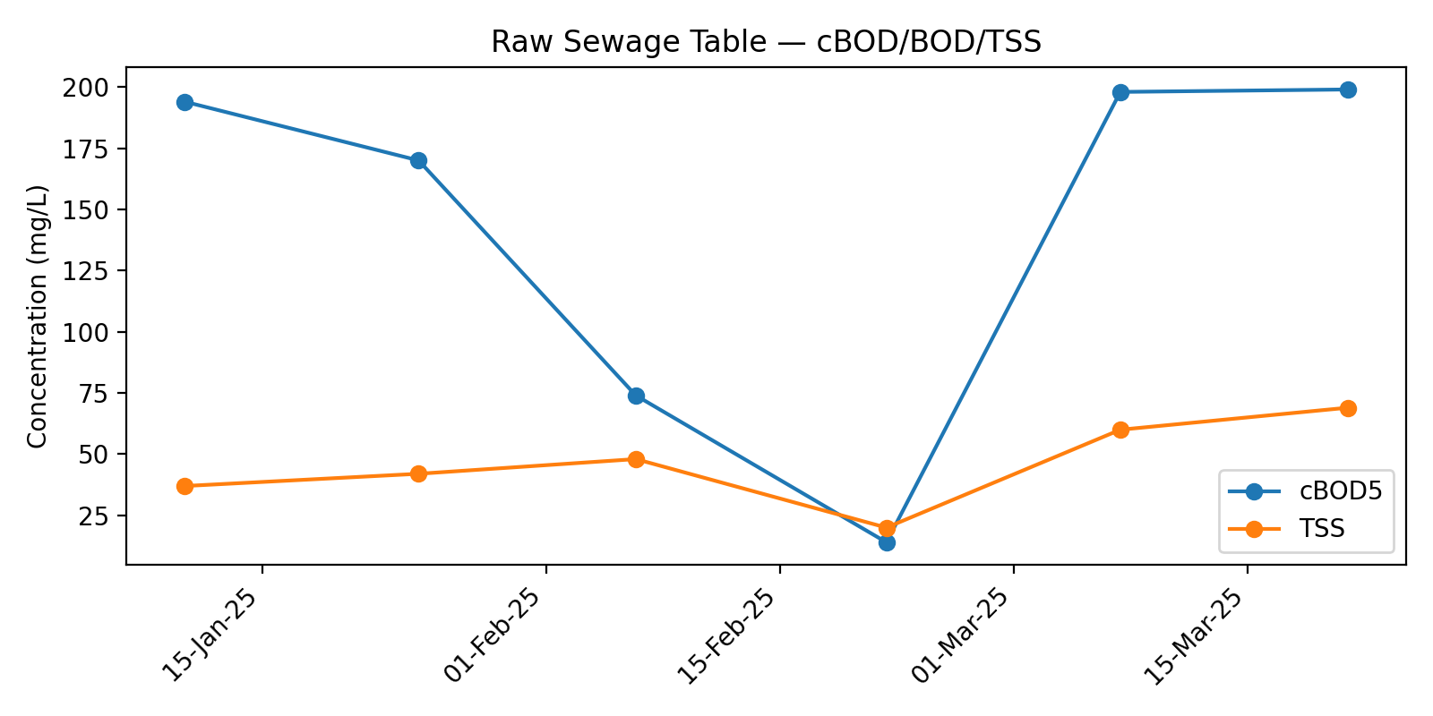

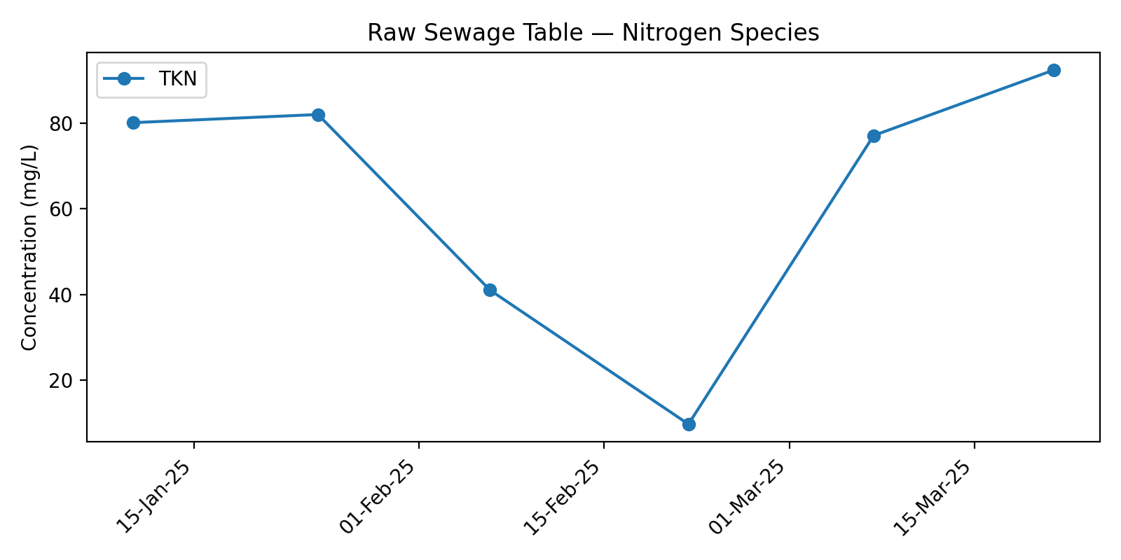

## Biofilter Effluent Table

|  |  |  |  |  |  |  |  |
| --- | --- | --- | --- | --- | --- | --- | --- |
| Date | cBOD5 | TSS | TKN | TAN | NO3 | NO2 | TN |
| 10-Jan-25 | 4 | 2 | 1.1 | 0.3 | 39.1 | 0.31 | 40.51 |
| 07-Mar-25 | 4 | 2 | 1.3 | 0.5 | 36.7 | 0.06 | 38.06 |

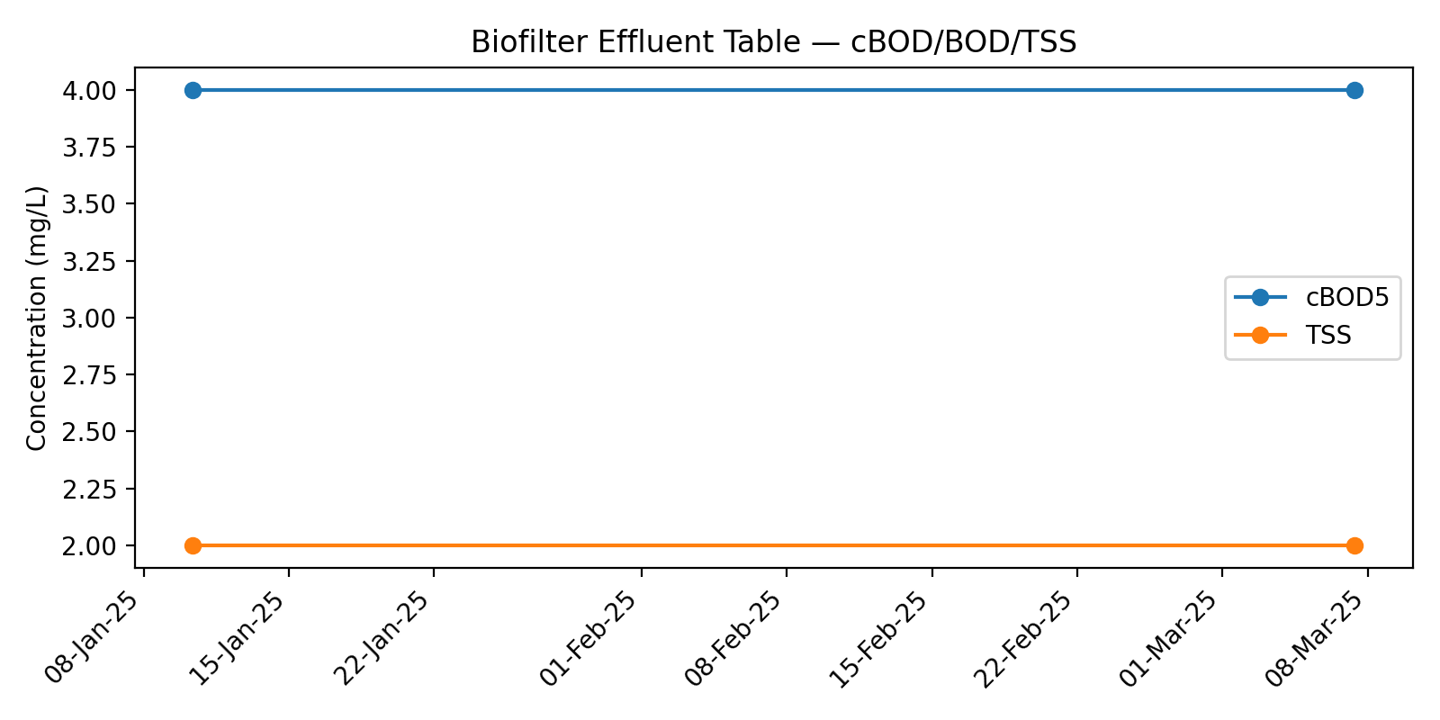

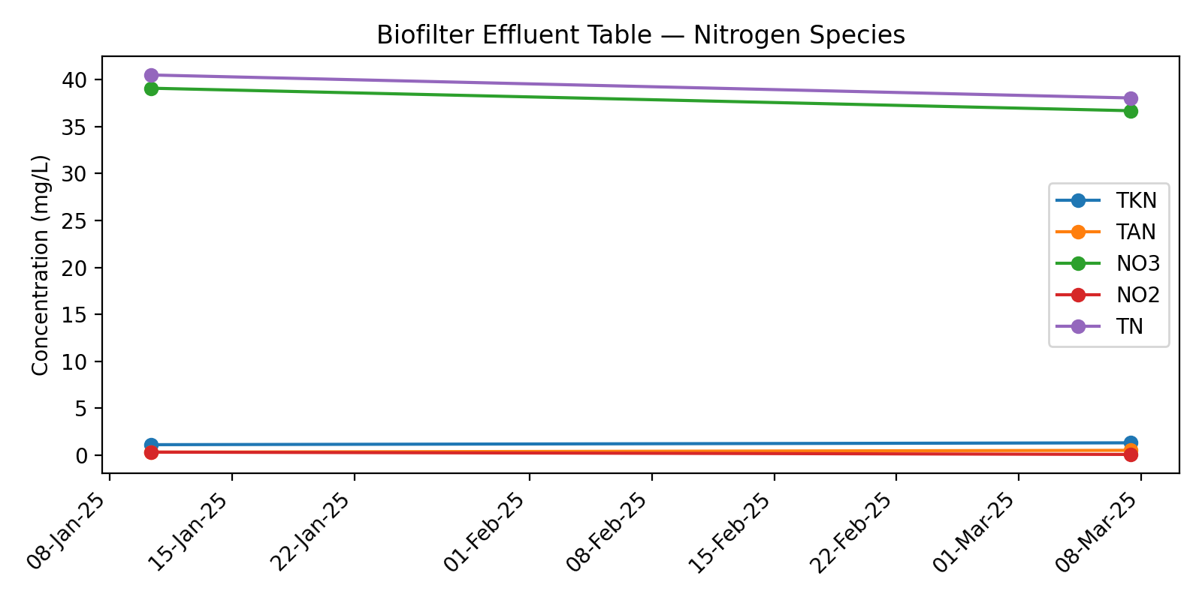

## WaterNOx Effluent Table

|  |  |  |  |  |  |  |  |
| --- | --- | --- | --- | --- | --- | --- | --- |
| Date | cBOD5 | TSS | TKN | TAN | NO3 | NO2 | TN |
| 10-Jan-25 | 37 | 38 | 2.3 | 0.9 | 7.13 | 2.66 | 12.09 |
| 07-Mar-25 | 4 | 6 | 3.9 | 3.6 | 21.9 | 0.41 | 26.21 |

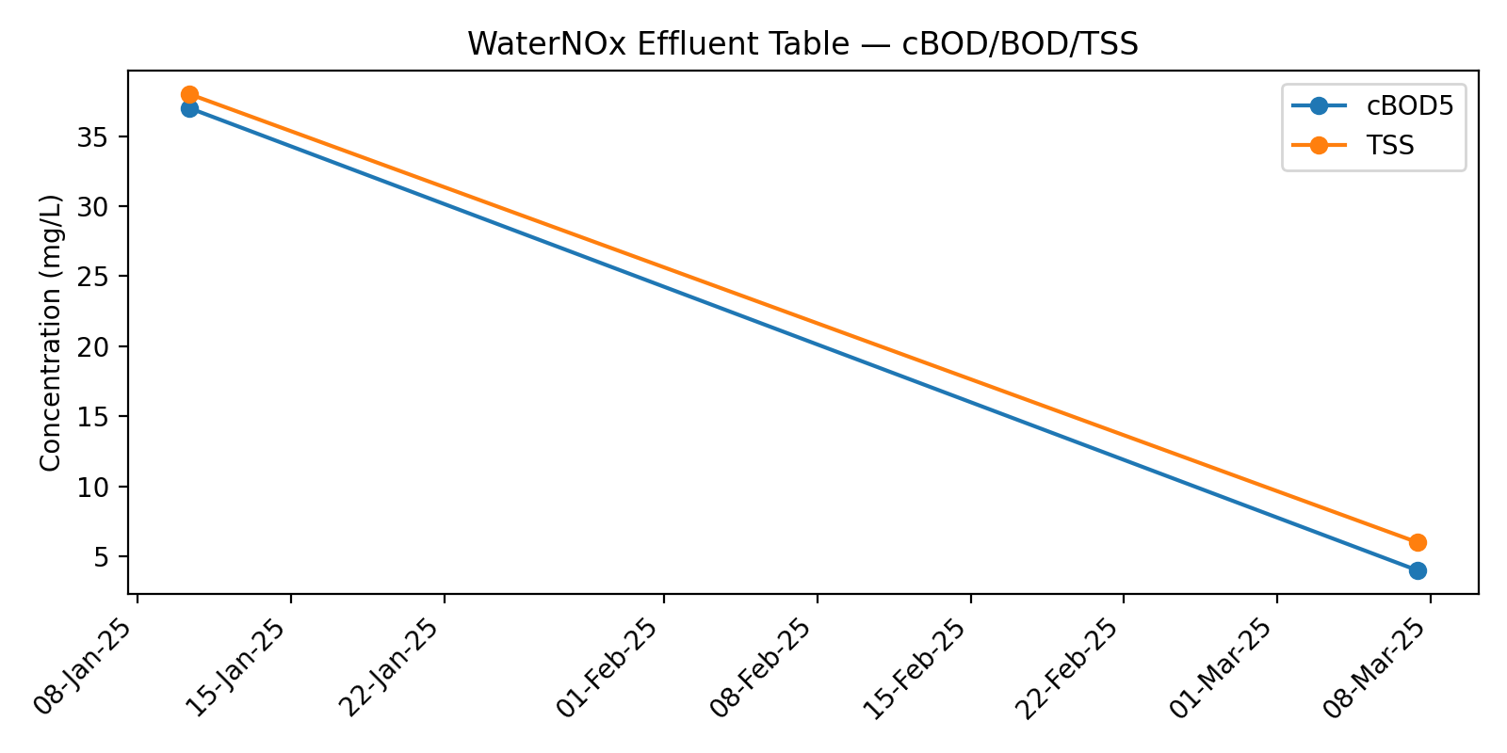

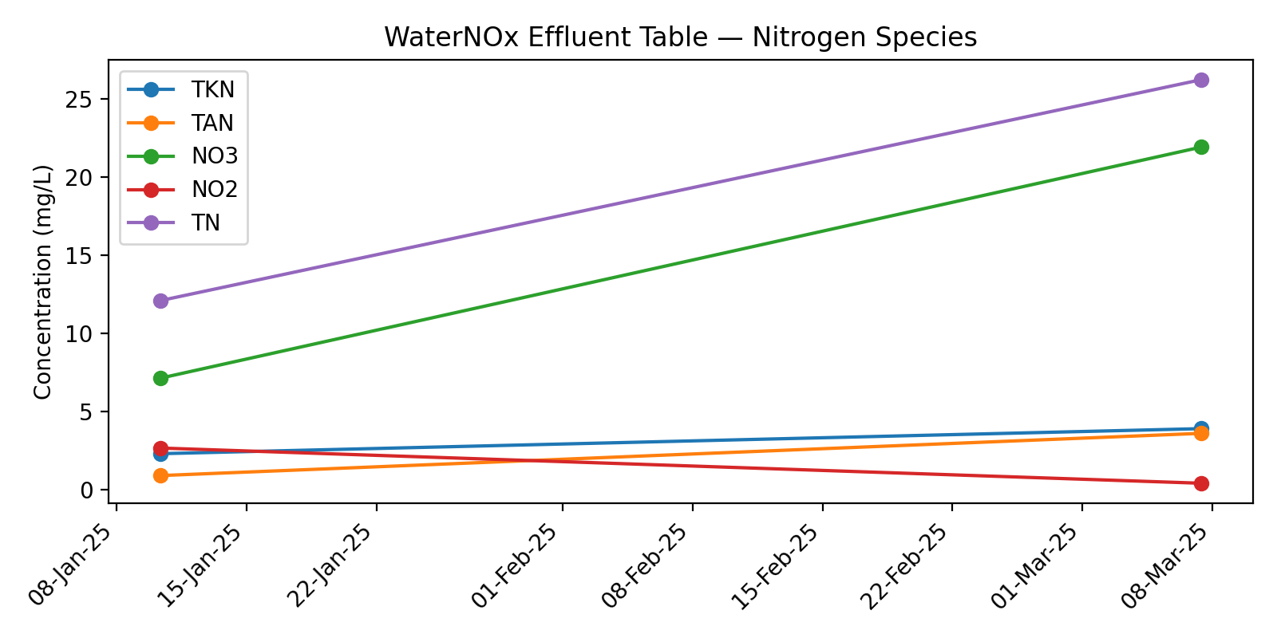

## Polisher Effluent Table

|  |  |  |  |  |  |  |  |
| --- | --- | --- | --- | --- | --- | --- | --- |
| Date | cBOD5 | TSS | TKN | TAN | NO3 | NO2 | TN |
| 10-Jan-25 | 10 | 3 | 1 | 0.1 | 13.6 | 0.44 | 15.04 |
| 24-Jan-25 | 22 | 8 | 1.1 | 0.1 | 4.4 | 0.24 | 5.74 |
| 06-Feb-25 | 4 | 8 | 0.6 | 0.1 | 6.61 | 0.03 | 7.24 |
| 21-Feb-25 | 4 | 3 | 0.9 | 0.2 | 11.6 | 0.03 | 12.53 |
| 07-Mar-25 | 4 | 4 | 0.9 | 0.7 | 26.1 | 0.13 | 27.13 |
| 21-Mar-25 | 4 | 2 | 1.9 | 0.5 | 26.5 | 0.04 | 28.44 |

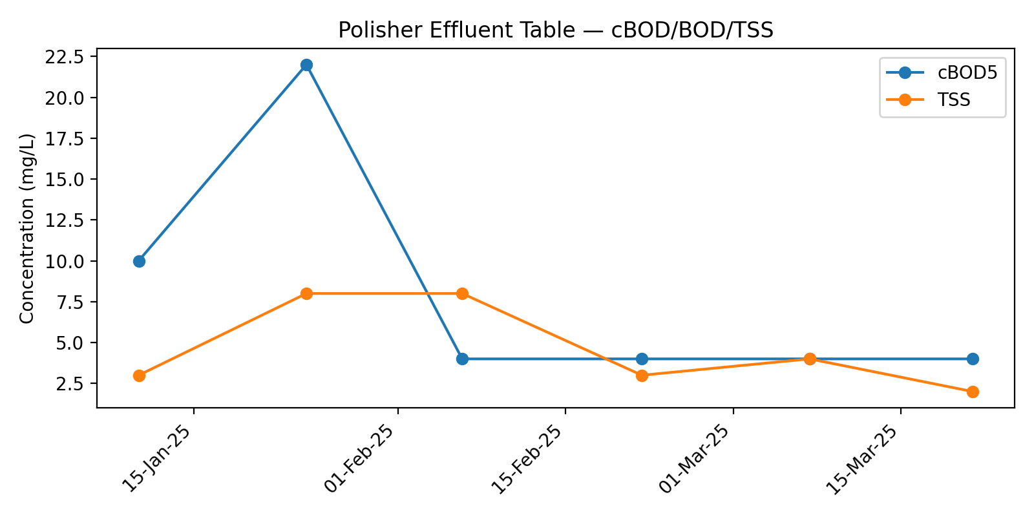

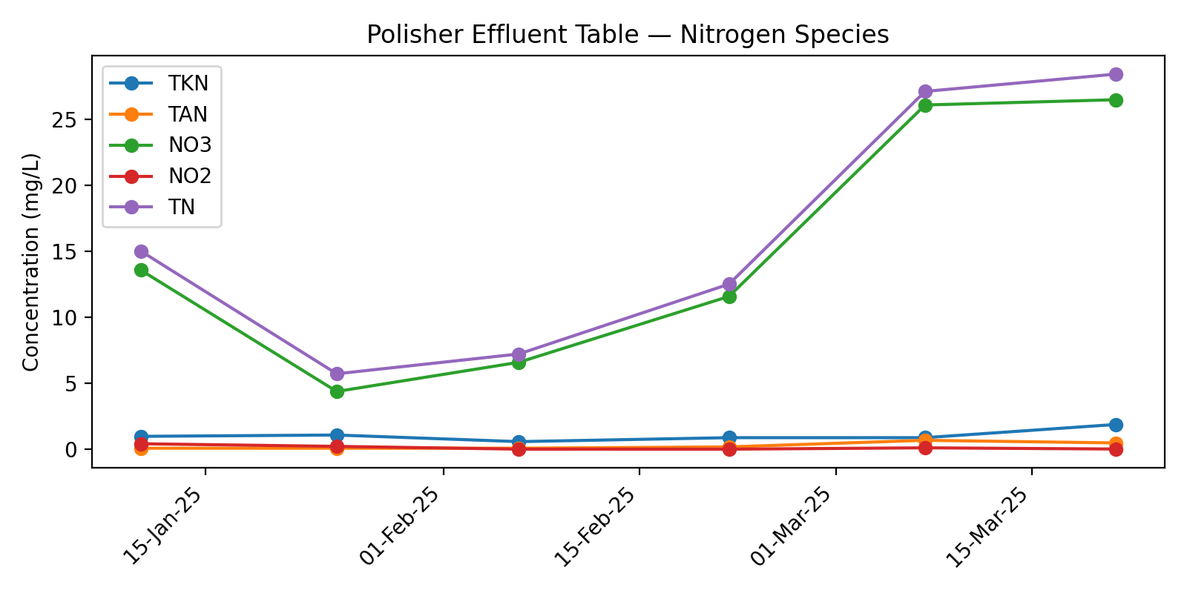

# Appendix B: Flow Data — March 2025

## Mar 25

|  |  |  |  |  |
| --- | --- | --- | --- | --- |
| Date | Flowmeter 1 Total (L) | Flowmeter 1 (L/day) | Total Daily Flow (L/day) |  |
| 01-Mar-25 | - |  | 2944 | *Smart Panel |
| 02-Mar-25 | - |  | 1920 |  |
| 03-Mar-25 | - |  | 6084 |  |
| 04-Mar-25 | - |  | 7186 |  |
| 05-Mar-25 | - |  | 12516 |  |
| 06-Mar-25 | - |  | 1970 |  |
| 07-Mar-25 | - |  | 6685 |  |
| 08-Mar-25 | - |  | 0 |  |
| 09-Mar-25 | - |  | 2434 |  |
| 10-Mar-25 | - |  | 6603 |  |
| 11-Mar-25 | - |  | 5812 |  |
| 12-Mar-25 | - |  | 6320 |  |
| 13-Mar-25 | - |  | 3271 |  |
| 14-Mar-25 | - |  | 5693 |  |
| 15-Mar-25 | - |  | 5080 |  |
| 16-Mar-25 | - |  | 4978 |  |
| 17-Mar-25 | - |  | 9219 |  |
| 18-Mar-25 | - |  | 9117 |  |
| 19-Mar-25 | - |  | 13023 |  |
| 20-Mar-25 | - |  | 9191 |  |
| 21-Mar-25 | - |  | 5959 |  |
| 22-Mar-25 | 4332100 | 9009 | 9009 |  |
| 23-Mar-25 | 4334809 | 2709 | 2709 |  |
| 24-Mar-25 | 4349935 | 15126 | 15126 |  |
| 25-Mar-25 | 4361467 | 11532 | 11532 |  |
| 26-Mar-25 | 4374949 | 13482 | 13482 |  |
| 27-Mar-25 | 4390525 | 15576 | 15576 |  |
| 28-Mar-25 | 4390525 | 0 | 0 |  |
| Total Flow (L) |  |  | 193439 |  |
| Average Flow (L/day) |  |  | 6909 |  |

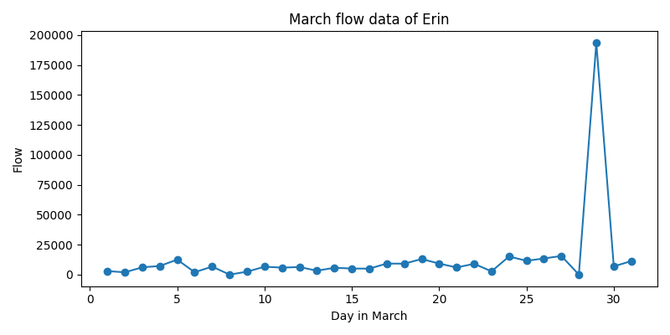

# Appendix C: Site Notes